

COS30045

Project Reflection

Ng Kang Jen

105002263

Table of Contents

Introduction 2

RelecTION FOR THE TEAM: 2

What we understand about Data Visualization Concepts 2

Applying Data Programming Concepts 2

Effective Visual Communication 5

Communication 5

Effective Team Communication 5

Adjusting Ourselves To Different Ways Of Communication 5

Fostering Positive Communication Culture 7

Balancing Communication and Tasks 7

Reflection on Myself: 8

Implement Feedback In Our Design 8

Research and Analysis 8

Idea Generation 9

Coding and Implementation 11

Web Development 13

My Reflection On Growth And Learning 13

Conclusion 13

Appendix 14

peer assessment 16

# Introduction

The project we started on data visualization offered an interesting examination of suicide rates in Asia compared to Europe. We strived to develop a visual tool that is user-friendly and easy to access, which would highlight current trends, offer insights for policymakers, support academic research, and improve public awareness. We successfully transformed intricate datasets containing thousands of data points into captivating, interactive visual displays. The project gave us a valuable chance to analyse the suicide rates in Asia and Europe and explore the potential causes. This procedure enhanced our technical abilities in making visualizations and also emphasized the diverse aspects of suicide worldwide and the reasons behind it.

# Reflection For The Team:

## What We Understand About Data Visualization Concepts

As we advanced in this project, we delved into the hands-on use of several data visualization techniques. We utilized appropriate visual tools such as choropleth maps, line charts, and grouped bar charts to showcase the dynamic and complex element contained in our data. Our approach in designing focuses on fostering user engagement, urging individuals to explore trends, analyse data, and uncover valuable insights on their own. Applying these techniques thoughtfully helped us convert intricate data into simple graphics, significantly improving stakeholders' comprehension of the suicide rate trends in Asia compared to Europe over time.

## Applying Data Programming Concepts

The strict implementation of data programming concepts played a crucial role in our visualization strategy. Implementing these principles was vital in streamlining, standardizing, and automating our processes, leading to a substantial enhancement in the project's overall productivity. We employed a strong tool, Python, for certain datasets to ensure the accuracy and integrity of the data. Giving importance to top-notch data was crucial for creating trustworthy visual representations, thus upholding the validity of our findings and analyses.

**FIGURE 1: The uncleaned version of the dataset that I used for comparing high, upper-middle, lower-middle, and low-income countries between Asia and Europe**

**FIGURE 2: The cleaned version of FIGURE 1**

**  
FIGURE 3: The uncleaned version of the dataset that I used to compare suicide rate between generations in Asia vs Europe**

**FIGURE 4: The cleaned dataset of FIGURE 3**

## Effective Visual Communication

The project emphasized the essential importance of visual communication in effectively displaying data. We used colour coding, interactive elements, labels for axis, and titles to change complicated data into easy-to-understand visualizations. Following these design principles diligently, greatly improved the user’s comprehension of trends and patterns of suicide, thereby amplifying the effect of the data that we discovered.

## **COMMUNICATION**

### Effective Team Communication

Establishing open and effective team communication was a key factor in the success of our project. We had daily meetings that took place both face-to-face and virtually, lasting the entire day. These meetings allowed us to cooperate on different parts of the project, generate ideas, solve problems, and stay informed on the status of our tasks. The project highlighted the great importance of effective communication among team members, enhancing our capacity to work together, encouraging shared understanding, and building a feeling of unity among all of us.

The consistency and profoundness of how we communicate enabled all of us to exchange and gain knowledge from each other's expertise, enhancing the current knowledge and skills that we have. The ongoing sharing of ideas, feedback, and knowledge played a key role in guiding the course of our project and upholding excellent work standards.

### Adjusting Ourselves To Different Ways of Communication

Though our communication routine was sometimes difficult, it helped us learn to adjust to various forms and timings of communication. We discovered how to blend face-to-face and virtual communication, utilizing the strengths of each for effective teamwork. For example, internet communication provided flexibility and convenience, enabling us to remain connected and efficient despite being physically separated. Alternatively, face-to-face meetings were found to be extremely beneficial for intricate project discussions, idea generation, and collaborative work.

**FIGURE 5: Our Google Meet meeting on 10/10/2024 about Project Stand Up 1**

**FIGURE 6: Second Google Meet meeting on 24/10/2024 about Project Stand Up 2**

**  
FIGURE 7: Third Google Meet meeting on 7/11/2024 about Project Stand Up 3**

**  
FIGURE 8: Fourth Google Meet meeting on 13/11/2024 about Project Stand Up 4  
  
FIGURE 9: Final Google Meet Meeting on 15/11/2024 to finalize everything and submission.**

### Fostering Positive Communication Culture

One key lesson we learned was how vital it is to foster a positive communication environment among team members. We aimed to establish a setting where all individuals could feel at ease expressing their thoughts, concerns, and suggestions. The culture of open communication encouraged participation from all team members and ensured that everyone's viewpoints were taken into account. It also assisted us in promptly recognizing and addressing any misinterpretations or tensions, strengthening our team's cohesion and collaborative problem-solving skills.

### Balancing Communication and Tasks

Our comprehensive communication plan also included effectively handling our communication to prevent it from taking away focus from our actual tasks. We discovered how to manage our conversations alongside our duties, focusing on important and efficient interactions while steering clear of unneeded interruptions. We established guidelines for respecting one another's time and space, knowing when to have in-depth conversations and when to prioritize the tasks that were given to us.

The focus on communication in this project has highlighted its importance as a vital skill, not just for completing successful projects but also for promoting strong teamwork, this is a teaching that all of us will utilize in upcoming works to strengthen teamwork, boost project results, and form solid, unified groups.

# REFLECTION ON MYSELF:

## Implement Feedback In Our Design

During the project, I realized the importance of lecturer feedback in guiding our design choices. I participated in gathering and studying feedback from my lecturer, then utilized this information to improve our visualizations. The exercise involved practicing empathy by embracing myself in the users' perspective in order to get a better understanding of their needs and challenges more effectively. This method focused on the user enabled us to develop visualizations that were not just visually attractive but also practical and easy to use.

## Research and Analysis

Before embarking on the design process, I was heavily involved in a thorough stage of research and analysis. I carefully analysed the datasets that is from the OECD website to find patterns, anomalies, and understand the importance of mental health and why when neglected, this often leads to suicide. Furthermore, I conducted additional research from external sources due to limited datasets from OECD to provide a more comprehensive understanding of the suicide pattern in Asia vs Europe. This thorough examination provided the groundwork for our design and development work, guaranteeing that our visualizations were based on strong data analysis.

**FIGURE 10: Datasets that I found from OECD website**

**  
FIGURE 11: Datasets that I found from external sources**

## Idea Generation

I played an active role in brainstorming and creating ideas for this project. Applying my knowledge of data visualization principles, I helped in creating initial design sketches for the visualizations we are suggesting. This project enabled everyone in the team to generate various visualization techniques, experimenting with different types of graphics before selecting the ones that most effectively conveyed our results.

**FIGURE 12: Initial sketch of my donut chart (Initial Chart for comparing income level countries suicide rate)**

**FIGURE 13: Initial sketch of my line chart (Initial Chart for comparing suicide rate between generations)  
  
**

**FIGURE 14: Initial sketch of my Mosaic Plot (Finalized Chart for income level comparison)**

**FIGURE 15: Initial sketch of my Circular Heat Map (Finalized Chart for generations comparison)**

## Coding and Implementation

I had a key part in transforming our planned charts into attractive, functional web-based interactive visualizations. With my knowledge of HTML, CSS, and JavaScript D3, I carefully wrote the essential components for our visualizations to be interactive. This required designing and formatting different components such as data markers, legends, axes, and tooltips, all while following guidelines for chart responsiveness, easy to access, and user-friendly interaction.

**FIGURE 16: Code Snippet for the Mosaic Plot**  
  
**FIGURE 17: Code Snippet for the Circular Heat Map**

## Web Development

Our collaborative endeavours resulted in the development of an ultimate, user-friendly online platform. My groupmate, Bryan Chow, designed the website and its layout. I helped him to insert pictures for the website and the description of the website. I also helped him to adjust whatever that is necessary after he is done with certain part. This experience was extremely valuable in applying web development practices in a real-world setting especially working as a team

**Collaboration and Communication**: This project highlighted the importance of effective communication and teamwork in achieving common objectives. Working together with my team, exchanging ideas, receiving feedback, and aligning my work with project goals not only helped the project to succeed but also improved my personal abilities, which in a way will give me benefits in the near future.

## My Reflection on Growth and Learning

This COS30045 project was a great experience to learn and grow for me. By enhancing my coding and web development abilities and strengthening the current teamwork skills that I have, I have gained valuable knowledge and experiences that will undoubtedly benefit me in the near future. One of the main areas where I saw growth was my capability in adjusting and absorbing feedback, not just from my groupmates but also from our lecturer, Mr Faizal. This method of development, while difficult, was fulfilling and played a major role in my growth as someone trying to survive in the IT field.

# Conclusion

The COS30045 project was a valuable and transformative opportunity, providing the group with essential skills and knowledge in data programming, visualization design, user experience, teamwork, and communication. Analysing the complication of suicide rates in Asia compared to Europe provided us with a distinctive viewpoint on the practical impacts of our research. The project emphasized the importance of data and how it is interpreted in deciding public policies, impacting the opinion of the public, and guiding strategies for the economy. We are dedicated to encouraging educated conversations and backing data-driven decision-making with our powerful visualizations, ultimately impacting global mental health policies. During this experience, we have not only created a helpful tool for comprehending suicide rates, but have also evolved personally and as a group, more equipped to overcome upcoming obstacles and create a beneficial change.

# Appendix

**FIGURE 18: I created a template of the Process Book for my group to fill in their part.**  
**FIGURE 19: I also helped created the Google Form survey for our group.**

**FIGURE 20: Example cleaning of master.csv which is the unfiltered version of the dataset I used for suicide rate comparison between generations in Asia vs Europe using Python.**  
  
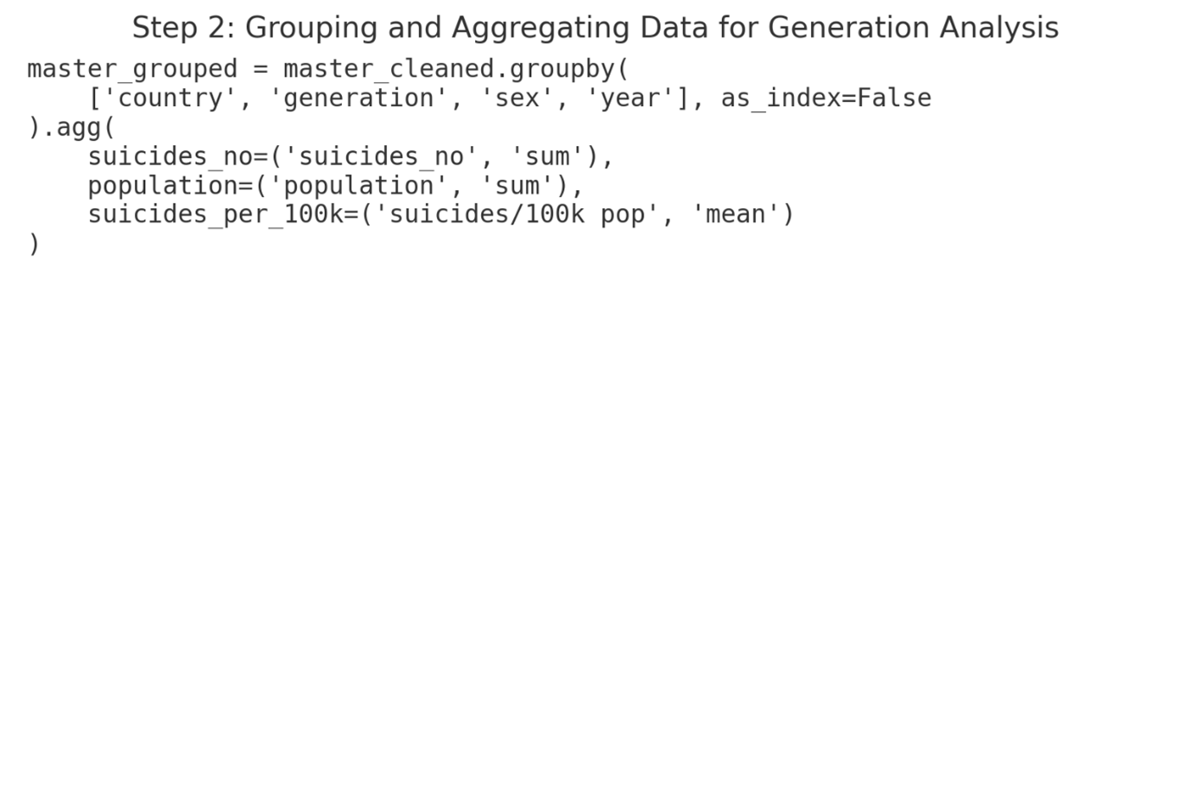  
**FIGURE 21: Grouping the cleaned data of generations for analysis using Python.**

# Peer Assessment (Out of 20 for each member)

|  |  |  |  |  |
| --- | --- | --- | --- | --- |
| Criteria | Ng Kang Jen (Me) | Bryan Chow Hou Nam | Hoo Ying Kit | Comments |
| Contribution to project: | 5 | 5 | 5 | All our contributions were equal in the project. We divided our work fairly during distribution of tasks. |
| Communication skills: | 5 | 5 | 5 | We didn’t have any issues in communicating. |
| Timeliness and Reliability: | 5 | 5 | 5 | We always made sure to have a meeting a day before the due date to finish up the tasks and we did. |
| Problem-Solving Skills | 4 | 5 | 5 | I made a mistake on one of my charts and I didn’t even realise it until the final presentation of the website. My groupmates are good. |
| Overall Performance | 19/20 | 20/20 | 20/20 |  |